QASM Specification

Comments
Lines beginning with # are comments:
# this is a comment

qubit Instruction
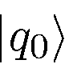
qubit sname,initval

qubit - define a qubit with a certain name (all qubits must be defined)
name = name of the qubit, eg q0 or j2 etc
initval = initial value (optional), eg 0

Optical Polarization Implementation:
A perfect source of single photons would be a single exited atom which emits light at an externally triggered point of time. Periodical repetition would yield light with perfect anti-bunching. Despite intensive research, such a source is not available yet.

Method 1: Photons Emitted after Decay of Excited Calcium Atoms
A good approach for many purposes are so called heralded single photons which are prepared from a pair of photons. Originally, heralded photons have been generated from an atomic beam of excited calcium atoms [Gra86]. Under decay, two photons are emitted almost simultaneously. One photon is detected. In this moment the existence of exactly one photon, namely the other component of the pair, is known. This photon is not yet absorbed and can be used for experiments. The principal setup of this technically demanding experiment is shown in the figure below.
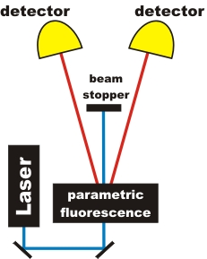Figure 1: Setup for heralded photons with parametric fluorescence (PDC)

Method 2: Parametric Down Conversion
Certain transparent crystals convert photons into pairs of photons. The conversion efficiency is quite low, but these crystals are very easy to handle and additionally the photon pairs are emitted in certain special directions when the crystal is excited by a laser. The process is called parametric down conversion, short PDC. In a setup shown in the figure below, two photons of equal wavelength 810nm are generated from a blue photon at 405nm.

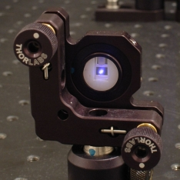Figure 2: PDC crystal, illuminated by 405nm laser light.The size of the crystal is 5mm x 5mm x 3mm length.
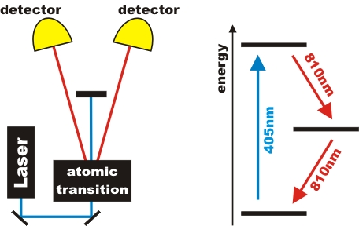Figure 1: Generation of photon pairs in an atomic cascade transition. Photons are registered by detectors D and T.

measure Instruction
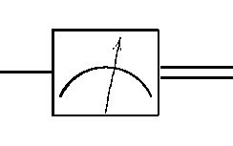
measure qubit

measure - measurement of qubit, gives classical bit (double-wire) output

Optical Polarization Implementation:
The linear polarization of light is often measured with a polarization filter. But for single photons it is better to use for the polarization measurement the combination of a polarization rotator (λ/2-plate) and a polarizing beam splitter. If the polarization of the light is horizontal it is transmitted at the polarizing beam splitter. If the polarization of the light is vertical it is reflected at a polarizing beam splitter. With a λ/2-plate you can change the direction of the light before the polarizing beam splitter. The advantage of the combination is that there is no loss of light. All light - transmitted or reflected - can be detected.

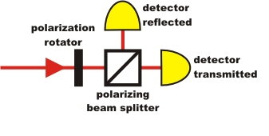Figure 3: Sketch of polarization rotator and polarizing beam splitter
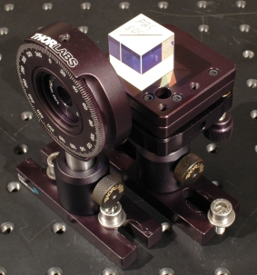Figure 4: Photograph of polarization rotator and polarizing beam splitter
Avalanche photodiodes (APDs) are used as detectors. These light sensitive elements emit a voltage pulse for any amount of incident light. APDs are binary detectors, i.e. they are not capable to determine the amount of light within a time interval, or photon numbers. As any technical device, APDs emit signals uncorrelated to the input, i.e. noise. About 1000 incidents per second are recorded in complete darkness (dark counts). When very dim light is incident on the APDs, 50% of the incident photons are actually detected. This quantum efficiency is quite high for such a sensitive detector. Photon rates larger than 1 million per second cause the APD to saturate. It takes 50 nanoseconds (0.000000005s) for the detector to recover to full sensitivity after detection of a photon. Additional electronics are used to protect the APD from excessive light intensity and damage. The figure below shows a set of four APD connected via optical fibres to an experiment.
Short voltage pulses at high repetition rates can be handled with electronics originally designed for high energy physics experiments. In order to simplify the setup, we use a programmable Time-Digital-Converter (TDC), which allows creating all electrical connections by software. The lower maximum count rate of the TDC is not a limitation for the purpose of quantum optics.
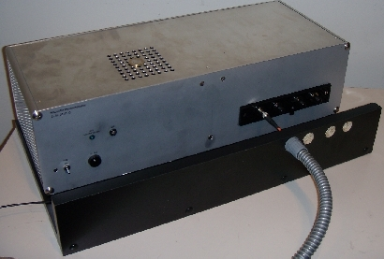Figure 5: Box of four APD single photon detectors with electronic overrange protection.
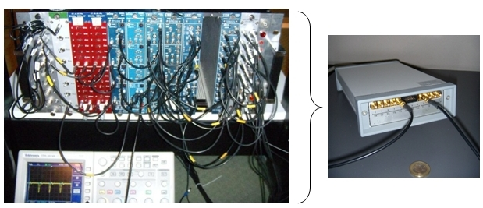Figure 6: Left: Data aquisition with NIM logic electronics. Right: Simplified data aquisition with programmable TDC.

Z Instruction
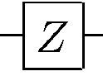
Z qubit

Z - single qubit operator implementing the Pauli-Z gate: 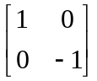

Optical Polarization Implementation:
Using the half-wave or 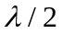-plate. A waveplate is a birefringent optical crystal which introduces a phase delay 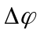 between the ordinary and extraordinary field components transmitted through it. Half-wave plates have 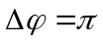.
Half-wave plates perform the following transformation of a photon:

S Instruction
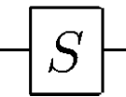
S qubit

S - single qubit operator implementing the phase S gate: 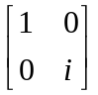

Optical Polarization Implementation:
Using the quarter-wave or 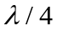-plate. A waveplate is a birefringent optical crystal which introduces a phase delay between the ordinary and extraordinary field components transmitted through it. Quarter-wave plates have 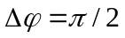.
Quarter-wave plates perform the following transformation of a photon:
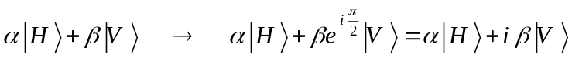

Examples:
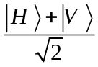(+45° polarization) → 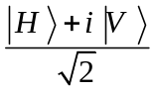(right circular polarization)
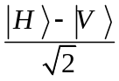(-45° polarization) → 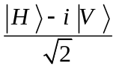(left circular polarization)
(right circular polarization)→ (-45° polarization)
(left circular polarization)→ (+45° polarization)

We see that a -plate with the optical axis oriented horizontally (or vertically) converts between the circular and ±45° polarizations.

T Instruction
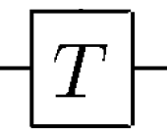
T qubit

T - single qubit operator implementing the phase 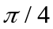 gate: 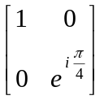

Optical Polarization Implementation:
Using the 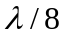-plate. A waveplate is a birefringent optical crystal which introduces a phase delay between the ordinary and extraordinary field components transmitted through it. -plates have 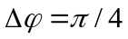.

qrand name
qentangle val
cbit name,initval
H qubit
X qubit
Y qubit
nop qubit
zero qubit
discard qubit
slash qubit
dmeter qubit
cnot ctrl,target
c-z ctrl,target
c-x ctrl,target
toffoli ctrl1,ctrl2,target
ZZ b1,b2
SS b1,b2
swap b1,b2
Utwo b1,b2
space qubit
def opname,nctrl,texsym
defbox opname,nbits,nctrl,texsym

Instruction Definitions
Where:
def - define a custom controlled single-qubit operation, with
opname = name of gate operation
nctrl = number of control qubits
texsym = latex symbol for the target qubit operation
defbox - define a custom muti-qubit-controlled multi-qubit operation, with
opname = name of gate operation
nbits = number of qubits it acts upon
nctrl = number of control qubits
texsym = latex symbol for the target qubit operation
cbit - define a cbit with a certain name (all cbits must be defined)
name = name of the cbit, eg c0
initval = initial value (optional), eg 0
H - single qubit operator ("hadamard")
X - single qubit operator
Y - single qubit operator
nop - single qubit operator, just a wire
space - single qubit operator, just an empty space
dmeter - measure qubit, showing "D" style meter instead of rectangular box
zero - replaces qubit with |0> state
discard - discard qubit (put "|" vertical bar on qubit wire)
slash - put slash on qubit wire
cnot - two-qubit CNOT
c-z - two-qubit controlled-Z gate
c-x - two-qubit controlled-X gate
swap - two-qubit swap operation
Utwo - two-qubit operation U
ZZ - two-qubit controlled-Z gate, symmetric notation; two filled circles
SS - two-qubit gate, symmetric; open squares
toffoli - three-qubit Toffoli gate

References:
- MIT Media Lab, Quantum circuit viewer: qasm2circ, http://www.media.mit.edu/quanta/qasm2circ/
- I. Lvovsky, Quantum Mechanics I- Optical Polarization Tutorial.
- Friedrich-Alexander Universitat, QuantumLab, http://www.didaktik.physik.uni-erlangen.de/quantumlab/english/index.html

